Task Blueprint Documentation

1-Task

Knowledge Base

1-What is Task
# Source: AI Source: Provided by: [Data Path: Persons Table -> ID Column: 1, Name_En Column: Motasem Essam] -> From: [ChatGPT] on [7/14/2025]
A task is a specific piece of work or activity intended to achieve a particular goal or objective.

2-What is Subtask
# Source: AI Source: Provided by: [Data Path: Persons Table -> ID Column: 1, Name_En Column: Motasem Essam] -> From: [ChatGPT] on [7/14/2025]
A subtask is a smaller, manageable part of a larger task.
- It breaks down a task into actionable steps that are easier to complete.
- Subtasks help you organize work, track progress, and avoid feeling overwhelmed by big tasks.

3-what is Mission
# Source: AI Source: Provided by: [Data Path: Persons Table -> ID Column: 1, Name_En Column: Motasem Essam] -> From: [ChatGPT] on [7/14/2025]
A mission is a broader purpose or overarching objective that guides multiple tasks or projects.
- It represents why you are doing something, the big-picture goal.
- Example: Mission = “Improve company productivity” → could involve many tasks like “Train employees,” “Upgrade software,” “Redesign workflow.”

4- what is MissionTaskReferences
# Source: AI Source: Provided by: [Data Path: Persons Table -> ID Column: 1, Name_En Column: Motasem Essam] -> From: [ChatGPT] on [7/14/2025]
MissionTaskReferences is a structured field that stores the list of Tasks linked to a specific Mission.
It acts as a reference map connecting the Mission to the Tasks that contribute to achieving it.
Purpose
- Identify which Tasks belong to the Mission
- Track execution order of Tasks
- Enable structured linking (not descriptive text)
- Support progress tracking and mission completion evaluation

Rules and Guidelines

1-Task
# Source: AI Source: Provided by: [Data Path: Persons Table -> ID Column: 1, Name_En Column: Motasem Essam] -> From: [ChatGPT] on [7/14/2025]
- Before starting, you must:
  - Determine exactly what you want to accomplish.
  - Determine how to check whether you have reached it (define completion criteria).
- A task can be simple or complex, and it may include subtasks—smaller, manageable components of the main task.
rules
- Define your goal clearly:
  - Example: Task = “Write a report” → define what sections and content must be included.
- Determine completion criteria:
  - Know how you will check whether the task or subtask is complete.
  - Example: “Introduction section contains at least 3 paragraphs summarizing background.”
- Tasks can have subtasks:
  - Task = “Write a report”
  - Subtasks = “Write introduction,” “Write methodology,” “Write conclusion”
- Tasks are actionable:
  - Every task should be actionable:
    - You should be able to perform steps to complete it.
    - Avoid vague or abstract goals like “Be productive.”

2-Subtask
# Source: AI Source: Provided by: [Data Path: Persons Table -> ID Column: 1, Name_En Column: Motasem Essam] -> From: [ChatGPT] on [7/14/2025]
Rules
1. Each Subtask Should Be Actionable
- A subtask must be a concrete action you can perform.
- Avoid vague statements like “Work on report” → instead use “Write introduction paragraph.”

2. Subtasks Must Contribute to the Main Task
- Every subtask should help complete its parent task.
- Example:
  - Task: “Write report”
  - Subtask: “Create table of results” → contributes directly to the report.

3. Define Completion Criteria
- Know exactly when a subtask is done.
- Example: “Introduction written with at least 3 paragraphs” or “Test case completed successfully.”

4. Break Down Large Tasks into Manageable Subtasks
- If a task is too big or complex, divide it into smaller subtasks.
- Example:
  - Task: “Prepare presentation”
  - Subtasks: “Create slides,” “Add images,” “Write speaker notes,” “Rehearse presentation”

5. Subtasks Can Be Sequential or Parallel
- Sequential: Must complete in order (e.g., draft → edit → finalize).
- Parallel: Can be done simultaneously by different people (e.g., research one section while writing another).

6. Track Subtask Progress
- Mark subtasks as completed when finished.
- Helps track overall progress of the main task.

Example: Task and Subtasks
Task: Prepare a training session for employees
Subtasks:
- Plan training content
  - Action: List topics to cover in the session.
  - Completion: A complete outline with at least 5 topics.
- Create presentation slides
  - Action: Design slides for each topic.
  - Completion: One slide per topic, visually clear, with key points.
- Prepare handouts
  - Action: Make a one-page summary for attendees.
  - Completion: Handouts printed or ready in PDF.
- Book training room
  - Action: Reserve a conference room for the session.
  - Completion: Room reserved with confirmation.
- Conduct training session
  - Action: Deliver the session to employees.
  - Completion: Session completed, attendance recorded.
- Collect feedback
  - Action: Prepare a feedback form and distribute it to attendees.
  - Completion: Feedback collected from at least 80% of participants.

3-Mission
# Source: AI Source: Provided by: [Data Path: Persons Table -> ID Column: 1, Name_En Column: Motasem Essam] -> From: [ChatGPT] on [7/14/2025]

1. A Mission is a Big-Picture Objective
- Defines the overall purpose or direction for tasks.
- Example: “Improve company productivity” or “Launch a new product.”

2. Missions Should Be Clear and Specific
- Avoid vague statements like “Do better work.”
- Make it meaningful and measurable, even if high-level.
- Example: “Increase customer satisfaction score by 20% in 6 months.”

3. Missions Guide Tasks
- Every task should align with the mission.
- Tasks are smaller actionable steps that move the mission forward.
- Example:
  - Mission = “Launch a new product”
  - Task = “Design marketing campaign” → directly supports the mission.

4. Missions Can Have Multiple Tasks
- Large missions are broken into tasks, which can then be broken into subtasks.
- Helps organize work and track progress.

5. Define Success Criteria for the Mission
- Know how you will measure if the mission is accomplished.
- Example:
  - Mission = “Improve company productivity”
  - Success criteria = “10% increase in output in 3 months.”

6. Missions Are Long-Term, Tasks Are Short-Term
- Missions usually span months or years; tasks/subtasks are completed in days or weeks.
- This hierarchy ensures daily actions connect to big-picture goals.

7. Review and Adjust Missions Periodically
- Missions may need updates if priorities change.
- Regularly check that tasks and subtasks still align with the mission.

Example Mission
Mission: Launch a new online learning platform
Mission Goal / Success Criteria:
- Platform is live within 6 months
- At least 500 users registered in the first month
- Positive feedback from at least 80% of early users

4-MissionTaskReferences
# Source: AI Source: Provided by: [Data Path: Persons Table -> ID Column: 1, Name_En Column: Motasem Essam] -> From: [ChatGPT] on [2/13/2026]
Structure
Each entry contains:
- OrderNumber → Sequential number of the Task inside the List
- TaskNumber → Sequential number of the Task inside the Mission
- TaskName → Name of the Task
- TaskID → Unique Task identifier (system reference)
- ShotsNumber → Number of attempts made to complete the Ta

Example
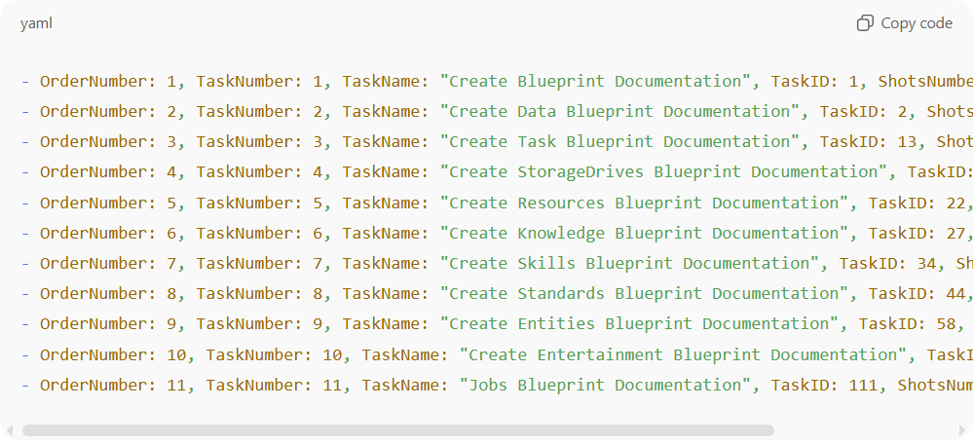
- OrderNumber: 1, TaskNumber: 1, TaskName: "Create Blueprint Documentation", TaskID: 1, ShotsNumber: 1
- OrderNumber: 2, TaskNumber: 2, TaskName: "Create Data Blueprint Documentation", TaskID: 2, ShotsNumber: 1
- OrderNumber: 3, TaskNumber: 3, TaskName: "Create Task Blueprint Documentation", TaskID: 13, ShotsNumber: 1
- OrderNumber: 4, TaskNumber: 4, TaskName: "Create StorageDrives Blueprint Documentation", TaskID: 19, ShotsNumber: 1
- OrderNumber: 5, TaskNumber: 5, TaskName: "Create Resources Blueprint Documentation", TaskID: 22, ShotsNumber: 1
- OrderNumber: 6, TaskNumber: 6, TaskName: "Create Knowledge Blueprint Documentation", TaskID: 27, ShotsNumber: 1
- OrderNumber: 7, TaskNumber: 7, TaskName: "Create Skills Blueprint Documentation", TaskID: 34, ShotsNumber: 1
- OrderNumber: 8, TaskNumber: 8, TaskName: "Create Standards Blueprint Documentation", TaskID: 44, ShotsNumber: 1
- OrderNumber: 9, TaskNumber: 9, TaskName: "Create Entities Blueprint Documentation", TaskID: 58, ShotsNumber: 1
- OrderNumber: 10, TaskNumber: 10, TaskName: "Create Entertainment Blueprint Documentation", TaskID: 84, ShotsNumber: 1
- OrderNumber: 11, TaskNumber: 11, TaskName: "Jobs Blueprint Documentation", TaskID: 111, ShotsNumber: 1

Rules
- OrderNumber
  - Sequential number for the position of the task in the list (top-to-bottom).
  - Starts at 1, increments by 1 for each task in the list.
  - Helps when displaying the list, regardless of the mission’s internal order.
- TaskNumber
  - Defines the visible order of the task inside the mission workflow.
  - Must be unique per mission.
  - Does not have to match OrderNumber.
- TaskName
  - Descriptive name of the task.
- TaskID
  - Unique identifier that exists in the Tasks table.
- ShotsNumber
  - Number of attempts made to complete the task.
  - Must be ≥ 1.

2-Tasks File

Knowledge Base

1-What is Tasks File
# Source: AI Source: Provided by: [Data Path: Persons Table -> ID Column: 1, Name_En Column: Motasem Essam] -> From: [ChatGPT] on [7/14/2025]
A tasks file is a structured document that defines, organizes, and tracks actionable tasks

2-What is actionable task
# Source: AI Source: Provided by: [Data Path: Persons Table -> ID Column: 1, Name_En Column: Motasem Essam] -> From: [ChatGPT] on [7/14/2025]
An actionable task is a specific, clearly defined instruction that can be acted upon or executed

Rules and Guidelines

1-Structure of a Tasks File

FILE STRUCTURE
# Source: AI Source: Provided by: [Data Path: Persons Table -> ID Column: 1, Name_En Column: Motasem Essam] -> From: [ChatGPT] on [7/14/2025]
task files follow this structure:
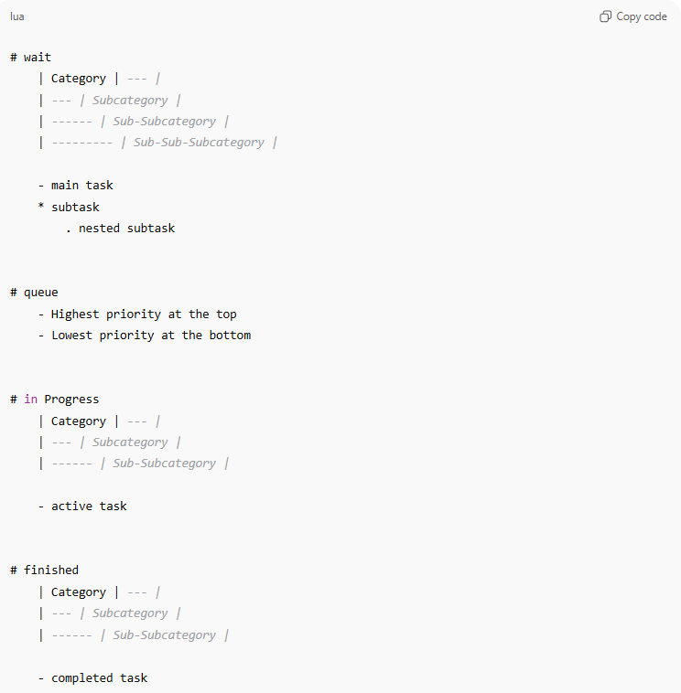
# wait
| Category | --- |
| --- | Subcategory |
| ------ | Sub-Subcategory |
| --------- | Sub-Sub-Subcategory |

- main task
* subtask
. nested subtask

# queue
- Highest priority at the top
- Lowest priority at the bottom

# in Progress
| Category | --- |
| --- | Subcategory |
| ------ | Sub-Subcategory |

- active task

# finished
| Category | --- |
| --- | Subcategory |
| ------ | Sub-Subcategory |

- completed task

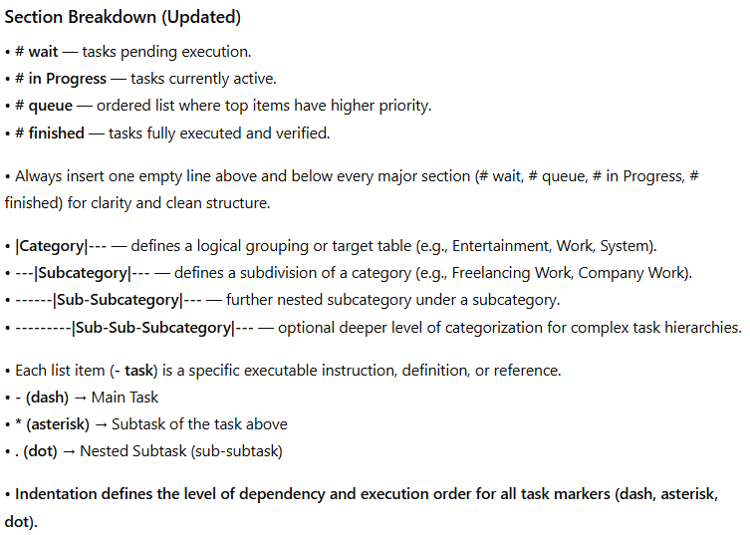
Section Breakdown (Updated)
• # wait — tasks pending execution.
• # in Progress — tasks currently active.
• # queue — ordered list where top items have higher priority.
• # finished — tasks fully executed and verified.
• Always insert one empty line above and below every major section (# wait, # queue, # in Progress, # finished) for clarity and clean structure.
• |Category|--- — defines a logical grouping or target table (e.g., Entertainment, Work, System).
• ---|Subcategory|--- — defines a subdivision of a category (e.g., Freelancing Work, Company Work).
• ------|Sub-Subcategory|--- — further nested subcategory under a subcategory.
• ---------|Sub-Sub-Subcategory|--- — optional deeper level of categorization for complex task hierarchies.
• Each list item (- task) is a specific executable instruction, definition, or reference.
• - (dash) → Main Task
• * (asterisk) → Subtask of the task above
• . (dot) → Nested Subtask (sub-subtask)
• Indentation defines the level of dependency and execution order for all task markers (dash, asterisk, dot).

Example
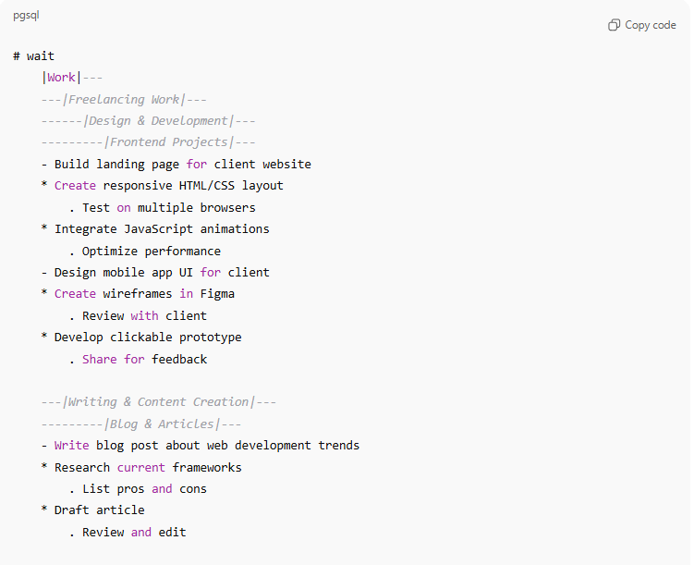
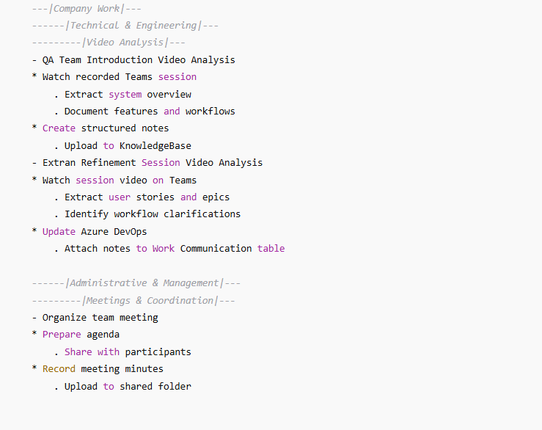
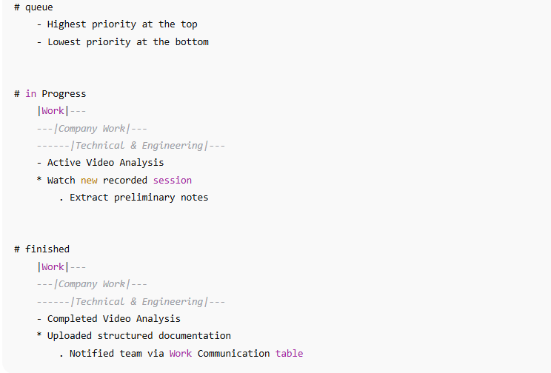

# wait
|Work|---
---|Freelancing Work|---
------|Design & Development|---
---------|Frontend Projects|---
- Build landing page for client website
* Create responsive HTML/CSS layout
. Test on multiple browsers
* Integrate JavaScript animations
. Optimize performance
- Design mobile app UI for client
* Create wireframes in Figma
. Review with client
* Develop clickable prototype
. Share for feedback

---|Writing & Content Creation|---
---------|Blog & Articles|---
- Write blog post about web development trends
* Research current frameworks
. List pros and cons
* Draft article
. Review and edit

---|Company Work|---
------|Technical & Engineering|---
---------|Video Analysis|---
- QA Team Introduction Video Analysis
* Watch recorded Teams session
. Extract system overview
. Document features and workflows
* Create structured notes
. Upload to KnowledgeBase
- Extran Refinement Session Video Analysis
* Watch session video on Teams
. Extract user stories and epics
. Identify workflow clarifications
* Update Azure DevOps
. Attach notes to Work Communication table

------|Administrative & Management|---
---------|Meetings & Coordination|---
- Organize team meeting
* Prepare agenda
. Share with participants
* Record meeting minutes
. Upload to shared folder

# queue
- Highest priority at the top
- Lowest priority at the bottom

# in Progress
|Work|---
---|Company Work|---
------|Technical & Engineering|---
- Active Video Analysis
* Watch new recorded session
. Extract preliminary notes

# finished
|Work|---
---|Company Work|---
------|Technical & Engineering|---
- Completed Video Analysis
* Uploaded structured documentation
. Notified team via Work Communication table

EXECUTION RULES
# Source: AI Source: Provided by: [Data Path: Persons Table -> ID Column: 1, Name_En Column: Motasem Essam] -> From: [ChatGPT] on [7/14/2025]
•Interpretation
- Every entry beginning with a dash - represents a discrete action or subtask.
- Tasks are executed top to bottom within each category.
- A subtask inherits its parent’s context and must be completed before the parent task can move to finished.
- Nested subtasks (dot level) define detailed steps or variations of a subtask.•
•Execution Priority
- Execute sections in order:
1️⃣ wait → queued tasks.
2️⃣ in Progress → active processing.
3️⃣ finished → completed verification log.

CATEGORY RULES
# Source: AI Source: Provided by: [Data Path: Persons Table -> ID Column: 1, Name_En Column: Motasem Essam] -> From: [ChatGPT] on [7/14/2025]
Each |Category|--- section has its purpose:
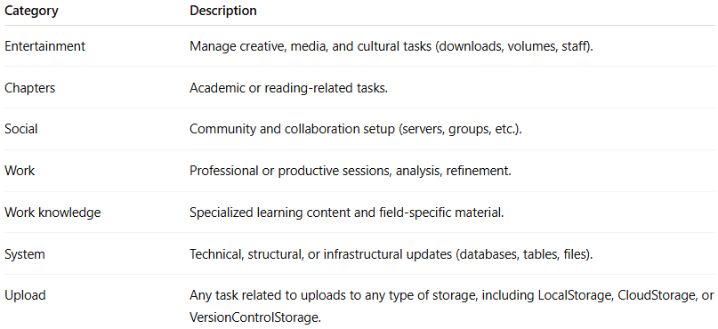
Category | Description
Entertainment | Manage creative, media, and cultural tasks (downloads, volumes, staff).
Chapters | Academic or reading-related tasks.
Social | Community and collaboration setup (servers, groups, etc.).
Work | Professional or productive sessions, analysis, refinement.
Work knowledge | Specialized learning content and field-specific material.
System | Technical, structural, or infrastructural updates (databases, tables, files).
Upload | Any task related to uploads to any type of storage, including LocalStorage, CloudStorage, or VersionControlStorage.

3-Chapters structure

Knowledge Base

1-What is chapters structure
# Source: AI Source: Provided by: [Data Path: Persons Table -> ID Column: 1, Name_En Column: Motasem Essam] -> From: [ChatGPT] on [7/14/2025]
chapters structure Is way to organize tasks I form of chapters and sections

Rules and Guidelines

1-Chapter Structure

Rules
# Source: AI Source: Provided by: [Data Path: Persons Table -> ID Column: 1, Name_En Column: Motasem Essam] -> From: [ChatGPT] on [7/14/2025]
- Every chapter contains multiple sections.
- Each section includes different types of tasks
- Each section task builds upon the previous one in content — forming a progressive learning flow, like climbing a staircase where each step prepares for the next.
- In any new chapter, you may introduce additional task types within sections to enrich and diversify the learning experience.
- You may also end or phase out an existing task type if it's no longer needed or relevant.

Chapter Structure Form
# Source: Self-created by [Motasem Essam -> motasem.essam.prototypedoteg.com@gmail.com] on [7/14/2025]
- Science:
- Computing:
- Subject:
- Skills:
- Social Science:

Example
# Source: Self-created by [Motasem Essam -> motasem.essam.prototypedoteg.com@gmail.com] on [7/14/2025]
- Science: Science
- Computing: Applied Science
- Subject: computer user skills - Computers - Computer Basics
- Skills: Theoretical - skill
- Social Science: Social Science

4-Shot

Knowledge Base

1-What is Shot
# Source: AI Source: Provided by: [Data Path: Persons Table -> ID Column: 1, Name_En Column: Motasem Essam] -> From: [ChatGPT] on [11/22/2025]
Shot is An attempt or effort to achieve a particular goal or complete a task, especially when the outcome is uncertain.

2-What is Snapshot
# Source: AI Source: Provided by: [Data Path: Persons Table -> ID Column: 1, Name_En Column: Motasem Essam] -> From: [ChatGPT] on [11/22/2025]
Snapshot is A brief or quick view, record, or representation of a situation, object, or moment, capturing its essential features at a particular point in time.

3- What is Session
# Source: AI Source: Provided by: [Data Path: Persons Table -> ID Column: 1, Name_En Column: Motasem Essam] -> From: [ChatGPT] on [11/22/2025]
Session is A continuous period devoted to a particular activity, task, or event, during which efforts, observations, or interactions are carried out.

4-Relation between task and Shot, Snapshot and Session
# Source: AI Source: Provided by: [Data Path: Persons Table -> ID Column: 1, Name_En Column: Motasem Essam] -> From: [ChatGPT] on [11/22/2025]
- Tasks are the unit of work that shots, snapshots, and sessions revolve around.
- A task is something you can attempt (shot), record progress (snapshot), and work on continuously (session).

✅ Key Relationships
- One task → one shot or multiple shots
  - (Multiple shots indicate extended or repeated attempts)
- One shot → one or multiple snapshots
  - (Snapshots act as checkpoints or milestones within a shot)
- One shot → one session or multiple sessions
  - One session can correspond to one shot
  - Multiple sessions can correspond to one shot or multiple shots
- One task -> can have divided to multiple subtasks
  - Which can use snapshots to save time and effort
  - Each subtask can have only one session or multiple session
    - one session only if session is success
    - multiple session mean all pervious session that before final is failure but final is success
✅ In short:
- Task = a specific goal or piece of work, clearly defined before starting, with a way to check completion
- Shot = attempt at the task
- Snapshot = checkpoint of the task or subtask
- Session = period of work on the task or its subtasks

5-Task Log
# Source: AI Source: Provided by: [Data Path: Persons Table -> ID Column: 1, Name_En Column: Motasem Essam] -> From: [ChatGPT] on [11/22/2025]
The Task Log is a structured record designed to track the detailed progress of tasks through shots, sessions. It provides a clear, chronological view of all efforts, attempts, and work periods related to a specific task, enabling accurate monitoring, analysis, and reporting.
Key Purposes:
- Capture Efforts (Shots): Record each attempt made to complete a task, marking its start and completion.
- Track Work Periods (Sessions): Document continuous periods of work within a shot, including success, failure, or ongoing progress.
- Optional Context & Work Details: Include related components, tables, or systems in parentheses () and describe activities or work done in square brackets [].
- Ensure Traceability: Maintain a structured, one-line format per session to keep logs readable, compact, and fully traceable.
- Support Analysis & Reporting: Aggregate total times, success/failure rates, and milestones for performance review, time management, and decision-making.
Structure Highlights:
- Shots: Represent attempts at achieving the task goal.
- Sessions: Continuous periods of work within a shot, clearly marked with state (_InProgress, _Success, _Failure).
- Annotations: Optional information about related tasks, systems, or work performed.
- Chronology & Totals: Tracks total time per session, shot, and task, facilitating aggregation and efficiency analysis.
Outcome:
The Task Execution Log ensures every attempt and session is documented systematically, providing transparency, accountability, and a clear path for task completion or iteration.

6-Task Total
# Source: AI Source: Provided by: [Data Path: Persons Table -> ID Column: 1, Name_En Column: Motasem Essam] -> From: [ChatGPT] on [11/22/2025]
Task Total is the final aggregated record of a task that summarizes all work performed across its entire lifecycle. It provides a complete overview of the task by combining all shots, sessions, and total time into a single consolidated summary.
It represents the full execution history of a task, showing how many attempts were made, how many sessions were used, where the data was recorded, and the total time spent until the task reached its final state.

The purpose of Task Total is to:
- Provide a single, clear summary of the entire task.
- Show total shots and sessions used to complete the task.
- Record the total time spent across all sessions.
- Reference the final data location (Data Path / Table / System).
- Help evaluate effort, efficiency, and completion history.
- Act as the final closure record of the task lifecycle.

Rules and Guidelines

1-Shot
# Source: AI Source: Provided by: [Data Path: Persons Table -> ID Column: 1, Name_En Column: Motasem Essam] -> From: [ChatGPT] on [11/22/2025]
Shot Rules
1. Definition Rule
- A shot is an attempt or effort to achieve a particular goal or complete a task, especially when the outcome is uncertain.
- Outcome is uncertain means:
  - You don’t know whether the task will be fully completed with this shot or if it will require additional shots (extended effort).
- Shot completion: A shot is considered complete when the result you specified is reached.Indicator:
- Indicators:
  - ▶ → marks the start of a shot
  - ✓ → marks the end of a shot (last session)
  - 🏁 → marks the final completed shot of the entire task (end of task)
2. Uniqueness Rule
- Each shot represents a distinct attempt. Multiple attempts on the same task are separate shots.
3. Scope Rule
- Focus on one task or goal per shot. Avoid combining multiple tasks into a single shot.
4. Documentation Rule
- Record each shot clearly with context:
  - Time
  - Task
  - Method or approach used
- This differentiates shots from snapshots and sessions.

2-Snapshot
# Source: AI Source: Provided by: [Data Path: Persons Table -> ID Column: 1, Name_En Column: Motasem Essam] -> From: [ChatGPT] on [11/22/2025]
Snapshot Rules
1. Definition Rule
- A snapshot is a brief or quick record, view, or representation of a situation, task, or event, capturing its essential features at a specific point or specific result in time.
- Snapshots act as checkpoints within a shot or session.
- “checkpoints” means a reference point or milestone that shows progress within a larger task or effort.
- Snapshots prevent restarting a task or subtask by recording what has already been achieved, so you can continue from the current state.
2. Timing Rule
- Snapshots capture a specific point in time, not a continuous process.
3. Documentation Rule
- Record snapshots with context:
  - Time
  - Task or subject
  - Purpose or goal
- Differentiates snapshots from shots (efforts) and sessions (periods).
4. Uniqueness Rule
- Each snapshot represents a single identifiable moment or result.
5. Storage & Organization Rule
- All snapshots must be stored inside a dedicated Snapshots folder.
- Inside the Snapshots folder:
  - Each snapshot has its own main folder, named after the snapshot.
  - Each snapshot folder contains versioned subfolders or files (e.g., v1, v2, v3).
  - Each snapshot folder must include a CHECKPOINTS.md file that clearly documents what each version (checkpoint) represents, including the progress made, the result achieved, or the current state at that point.
- Versions represent progress checkpoints within the same snapshot.

CHECKPOINTS.md — FormatCHECKPOINTS.md — Format
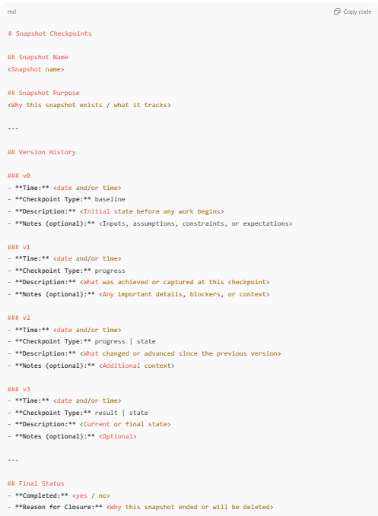
# Snapshot Checkpoints

## Snapshot Name
<Snapshot name>

## Snapshot Purpose
<Why this snapshot exists / what it tracks>

---

## Version History

### v0
- **Time:** <date and/or time>
- **Checkpoint Type:** baseline
- **Description:** <Initial state before any work begins>
- **Notes (optional):** <Inputs, assumptions, constraints, or expectations>

### v1
- **Time:** <date and/or time>
- **Checkpoint Type:** progress
- **Description:** <What was achieved or captured at this checkpoint>
- **Notes (optional):** <Any important details, blockers, or context>

### v2
- **Time:** <date and/or time>
- **Checkpoint Type:** progress | state
- **Description:** <What changed or advanced since the previous version>
- **Notes (optional):** <Additional context>

### v3
- **Time:** <date and/or time>
- **Checkpoint Type:** result | state
- **Description:** <Current or final state>
- **Notes (optional):** <Optional>

---

## Final Status
- **Completed:** <yes / no>
- **Reason for Closure:** <Why this snapshot ended or will be deleted>

CHECKPOINTS.md — Example
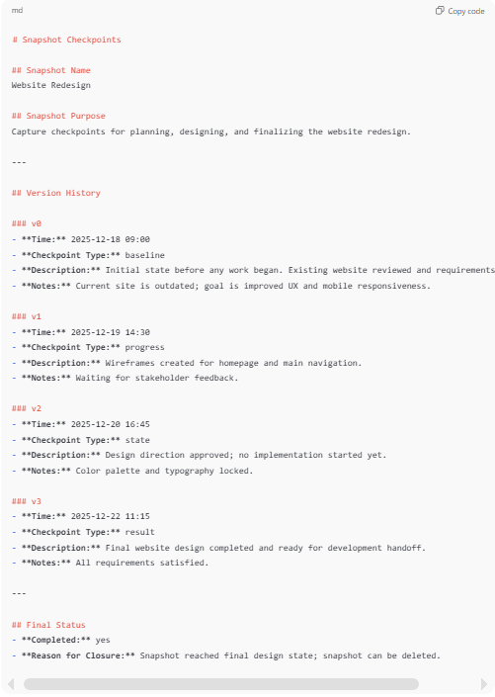
# Snapshot Checkpoints

## Snapshot Name
Website Redesign

## Snapshot Purpose
Capture checkpoints for planning, designing, and finalizing the website redesign.

---

## Version History

### v0
- **Time:** 2025-12-18 09:00
- **Checkpoint Type:** baseline
- **Description:** Initial state before any work began. Existing website reviewed and requirements collected.
- **Notes:** Current site is outdated; goal is improved UX and mobile responsiveness.

### v1
- **Time:** 2025-12-19 14:30
- **Checkpoint Type:** progress
- **Description:** Wireframes created for homepage and main navigation.
- **Notes:** Waiting for stakeholder feedback.

### v2
- **Time:** 2025-12-20 16:45
- **Checkpoint Type:** state
- **Description:** Design direction approved; no implementation started yet.
- **Notes:** Color palette and typography locked.

### v3
- **Time:** 2025-12-22 11:15
- **Checkpoint Type:** result
- **Description:** Final website design completed and ready for development handoff.
- **Notes:** All requirements satisfied.

---

## Final Status
- **Completed:** yes
- **Reason for Closure:** Snapshot reached final design state; snapshot can be deleted.

6. Lifecycle & Deletion Rule
- Snapshots are temporary by design.
- Once the snapshot reaches its final intended point or purpose:
  - All versions of that snapshot are deleted.
- Deletion confirms that the snapshot has fulfilled its role and is no longer needed.

3-Session
# Source: AI Source: Provided by: [Data Path: Persons Table -> ID Column: 1, Name_En Column: Motasem Essam] -> From: [ChatGPT] on [11/22/2025]
Session Rules
1. Definition Rule
- A session is a continuous period devoted to a particular one task or subtask.
- A session can represent success or failure.
- If the session fails, record what is fail and what is the reason for the failure and attempt to determine the cause.
  - If you cannot determine the root cause immediately, try to identify it in a subsequent session.
- Session Success: A session is considered successful if it achieves the intended goal of the task or any of its subtasks.
  - You don’t have to complete the entire main task in one session for it to be a success. Completing a task or subtask or a defined portion also counts.
  - Example:
    - Main task: Write a report
    - Session goal: Complete the introduction section (subtask)
    - If the introduction is completed, the session is successful, even if the rest of the report is unfinished.

- Session Failure (with subtasks)
  - A session fails if the subtask or portion it aims to achieve is not completed or blocked.
  - In this case, you record the reason and plan to continue in a subsequent session.

2. Continuity Rule
- A session should be continuous in time, not broken into unrelated periods.
- Represents an ongoing block of work or observation.

3. Scope Rule
- Covers all related activities within the session.
- Avoid including unrelated tasks.

4. Documentation Rule
- Record the session clearly with context:
  - Start and end time
  - Purpose or goal
  - Tasks performed, shots taken, snapshots captured
- This helps differentiate sessions from individual shots or snapshots.
- Shot states:
  - start → first session of the shot
  - continuous → middle sessions
  - end → last session (mark ✓ at end time)
- Sessions:
  - Each line represents one continuous work period.
  - Number sessions sequentially within the shot.
- Session One-Line Format
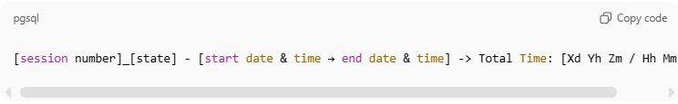
[session number]_[state] - [start date & time → end date & time] -> Total Time: [Xd Yh Zm / Hh Mm / Mm]

Notes:
- State indicates whether the session was successful or failed:
  - _InProgress → The session is currently active and work is ongoing.
  - _Success → the session achieved its intended goal (task or subtask).
  - _Failure → the session did not complete the intended goal.
- Each line represents one continuous session.

Example
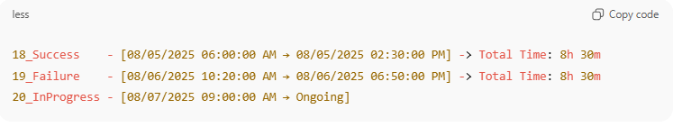
18_Success - [08/05/2025 06:00:00 AM → 08/05/2025 02:30:00 PM] -> Total Time: 8h 30m
19_Failure - [08/06/2025 10:20:00 AM → 08/06/2025 06:50:00 PM] -> Total Time: 8h 30m
20_InProgress - [08/07/2025 09:00:00 AM → Ongoing]

Notes:
session_state:
  - _InProgress → session is currently active and work is ongoing
  - _Success → session achieved its intended goal (task/subtask)
  - _Failure → session did not achieve the goal

4-Task Log
# Source: AI Source: Provided by: [Data Path: Persons Table -> ID Column: 1, Name_En Column: Motasem Essam] -> From: [ChatGPT] on [11/22/2025]•
Each line represents one session inside a shot, with both states clearly shown.

- Shot with Sessions – One-Line Format
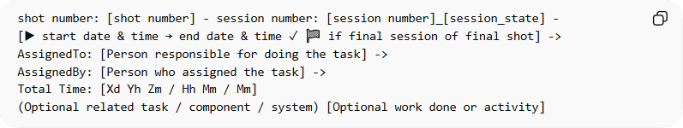
shot number: [shot number] - session number: [session number]_[session_state] -
[▶ start date & time → end date & time ✓ 🏁 if final session of final shot] ->
AssignedTo: [Person responsible for doing the task] ->
AssignedBy: [Person who assigned the task] ->
Total Time: [Xd Yh Zm / Hh Mm / Mm]
(Optional related task / component / system) [Optional work done or activity]

Example: Shot 1 with 20 Sessions
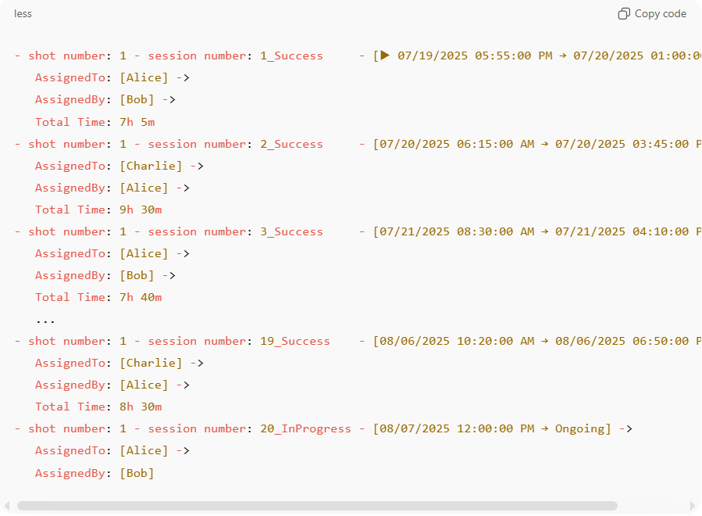
- shot number: 1 - session number: 1_Success - [▶ 07/19/2025 05:55:00 PM → 07/20/2025 01:00:00 AM] ->
AssignedTo: [Alice] ->
AssignedBy: [Bob] ->
Total Time: 7h 5m
- shot number: 1 - session number: 2_Success - [07/20/2025 06:15:00 AM → 07/20/2025 03:45:00 PM] ->
AssignedTo: [Charlie] ->
AssignedBy: [Alice] ->
Total Time: 9h 30m
- shot number: 1 - session number: 3_Success - [07/21/2025 08:30:00 AM → 07/21/2025 04:10:00 PM] ->
AssignedTo: [Alice] ->
AssignedBy: [Bob] ->
Total Time: 7h 40m
...
- shot number: 1 - session number: 19_Success - [08/06/2025 10:20:00 AM → 08/06/2025 06:50:00 PM] ->
AssignedTo: [Charlie] ->
AssignedBy: [Alice] ->
Total Time: 8h 30m
- shot number: 1 - session number: 20_InProgress - [08/07/2025 12:00:00 PM → Ongoing] ->
AssignedTo: [Alice] ->
AssignedBy: [Bob]

Example: Shot 2 with 8 Sessions
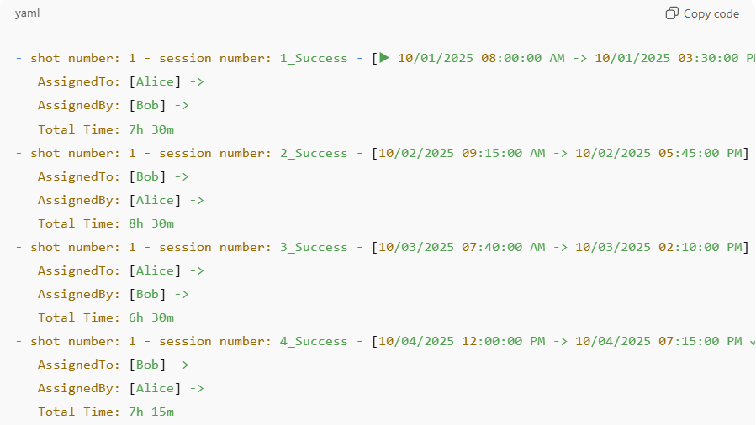
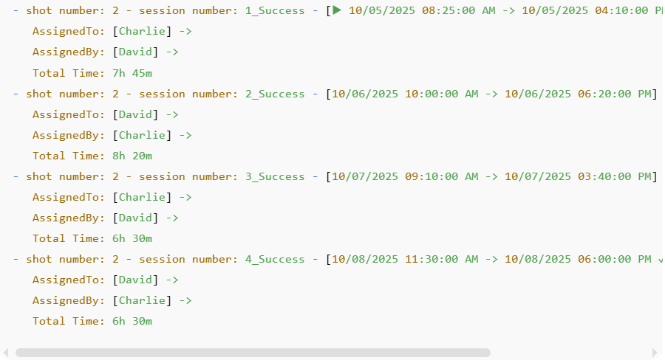
- shot number: 1 - session number: 1_Success - [▶ 10/01/2025 08:00:00 AM → 10/01/2025 03:30:00 PM] ->
AssignedTo: [Alice] ->
AssignedBy: [Bob] ->
Total Time: 7h 30m

- shot number: 1 - session number: 2_Success - [10/02/2025 09:15:00 AM → 10/02/2025 05:45:00 PM] ->
AssignedTo: [Bob] ->
AssignedBy: [Alice] ->
Total Time: 8h 30m

- shot number: 1 - session number: 3_Success - [10/03/2025 07:40:00 AM → 10/03/2025 02:10:00 PM] ->
AssignedTo: [Alice] ->
AssignedBy: [Bob] ->
Total Time: 6h 30m

- shot number: 1 - session number: 4_Success - [10/04/2025 12:00:00 PM → 10/04/2025 07:15:00 PM ✓] ->
AssignedTo: [Bob] ->
AssignedBy: [Alice] ->
Total Time: 7h 15m

- shot number: 2 - session number: 1_Success - [▶ 10/05/2025 08:25:00 AM → 10/05/2025 04:10:00 PM] ->
AssignedTo: [Charlie] ->
AssignedBy: [David] ->
Total Time: 7h 45m

- shot number: 2 - session number: 2_Success - [10/06/2025 10:00:00 AM → 10/06/2025 06:20:00 PM] ->
AssignedTo: [David] ->
AssignedBy: [Charlie] ->
Total Time: 8h 20m

- shot number: 2 - session number: 3_Success - [10/07/2025 09:10:00 AM → 10/07/2025 03:40:00 PM] ->
AssignedTo: [Charlie] ->
AssignedBy: [David] ->
Total Time: 6h 30m

- shot number: 2 - session number: 4_Success - [10/08/2025 11:30:00 AM → 10/08/2025 06:00:00 PM ✓ 🏁] ->
AssignedTo: [David] ->
AssignedBy: [Charlie] ->
Total Time: 6h 30m

- optional annotations for sessions
  - Related task, table, component, or system → use () parentheses
  - Activities or work done inside the session → use [] square brackets

Session Format with Side-by-Side Optional Annotations
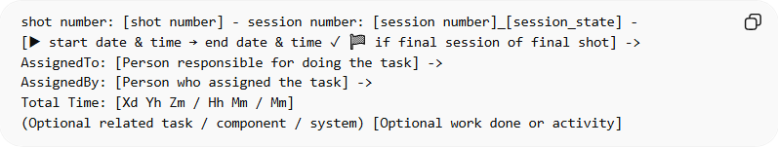
shot number: [shot number] - session number: [session number]_[session_state] -
[▶ start date & time → end date & time ✓ 🏁 if final session of final shot] ->
AssignedTo: [Person responsible for doing the task] ->
AssignedBy: [Person who assigned the task] ->
Total Time: [Xd Yh Zm / Hh Mm / Mm]
(Optional related task / component / system) [Optional work done or activity]
Example with Related Task 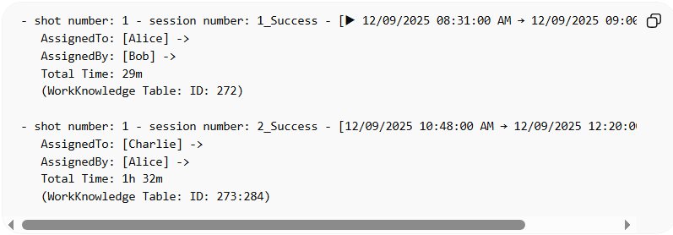
- shot number: 1 - session number: 1_Success - [▶ 12/09/2025 08:31:00 AM → 12/09/2025 09:00:00 AM] ->
AssignedTo: [Alice] ->
AssignedBy: [Bob] ->
Total Time: 29m
(WorkKnowledge Table: ID: 272)

- shot number: 1 - session number: 2_Success - [12/09/2025 10:48:00 AM → 12/09/2025 12:20:00 PM ✓ 🏁] ->
AssignedTo: [Charlie] ->
AssignedBy: [Alice] ->
Total Time: 1h 32m
(WorkKnowledge Table: ID: 273:284)

Example with Work Done
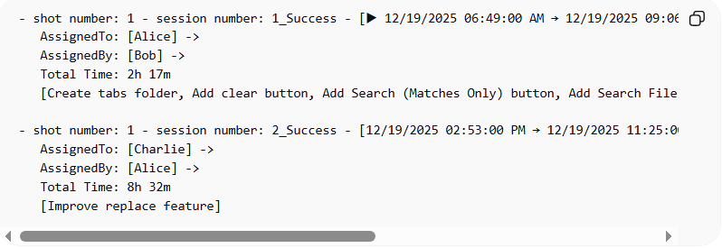
- shot number: 1 - session number: 1_Success - [▶ 12/19/2025 06:49:00 AM → 12/19/2025 09:06:00 AM] ->
AssignedTo: [Alice] ->
AssignedBy: [Bob] ->
Total Time: 2h 17m
[Create tabs folder, Add clear button, Add Search (Matches Only) button, Add Search File Paths Only button, file paths bold, display dialog find field is empty]

- shot number: 1 - session number: 2_Success - [12/19/2025 02:53:00 PM → 12/19/2025 11:25:00 PM ✓ 🏁] ->
AssignedTo: [Charlie] ->
AssignedBy: [Alice] ->
Total Time: 8h 32m
[Improve replace feature]

Example with Both
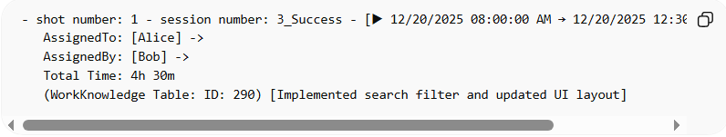
- shot number: 1 - session number: 3_Success - [▶ 12/20/2025 08:00:00 AM → 12/20/2025 12:30:00 PM ✓ 🏁] ->
AssignedTo: [Alice] ->
AssignedBy: [Bob] ->
Total Time: 4h 30m
(WorkKnowledge Table: ID: 290) [Implemented search filter and updated UI layout]

Notes
- () → Optional related task, component, system, table, etc.
- [] → Optional description of work done or activity.
- Both are side by side, not nested, and both are optional.
- This format keeps your session logs compact, readable, and fully traceable.

5-Task Total
# Source: AI Source: Provided by: [Data Path: Persons Table -> ID Column: 1, Name_En Column: Motasem Essam] -> From: [ChatGPT] on [11/22/2025]
A Task Total record includes:
- Total number of shots used for the task.
- Total number of sessions across all shots.
- Total accumulated time (sum of all sessions).
- Data Path or storage reference of the task result.
- Breakdown per shot (optional but recommended).

Conceptual Role in Your System
- Task → The goal or work to be completed.
- Shot → Attempts made to achieve the task.
- Session → Time periods spent working on the task.
- Task Total → The final aggregated summary of the entire task.

Example 1 – Single Shot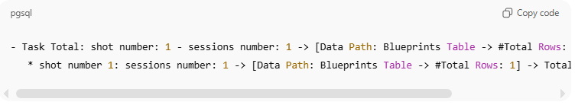
- Task Total: shot number: 1 - sessions number: 1 -> [Data Path: Blueprints Table -> #Total Rows: 1] -> Total Time: 10m
* shot number 1: sessions number: 1 -> [Data Path: Blueprints Table -> #Total Rows: 1] -> Total Time: 10m

Example 2 – more than one shot
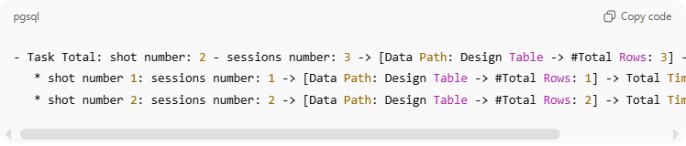
- Task Total: shot number: 2 - sessions number: 3 -> [Data Path: Design Table -> #Total Rows: 3] -> Total Time: 45m
* shot number 1: sessions number: 1 -> [Data Path: Design Table -> #Total Rows: 1] -> Total Time: 15m
* shot number 2: sessions number: 2 -> [Data Path: Design Table -> #Total Rows: 2] -> Total Time: 30m

